Introduction
It is time tested by now that the future of Pollution Control and Environmental Management in any country does not rest solely on regulatory mechanisms. Voluntary and participatory mechanisms have to play bigger roles. Wastage have to be minimized, resources consumed more prudently and the urge to conserve embedded in our cultures in order to achieve the desired levels of environmental sustainability. Looking into the mirror always helps to improve and so does emulating better performers. With the regulatory mechanism severely crunched for human resources, voluntary approaches will need to pick up. The traditional regulatory approach to Pollution control, the first wave, was followed by the second wave of market based economic instruments like pollution charges, product charges, user fees, performance bonds, liability payments, non compliance fees, deposit refund schemes and tradable permits. The Water (Prevention and Control of Pollution) Cess Act , 1977 has been a very effective economic instrument in regulating the use of water. Public disclosure systems have followed as the third wave. This promised creation of better market opportunities, improvements in environmental performance, increased confidence of investors, insurers and financial institutions, improved relationships with local communities, regulators and non governmental organizations. Public disclosures also help build societies confidence and protect corporates from the fear of loosing significant economic values of good reputation.
The provision for Environmental Audit (Statement) as prescribed under the Environmental Protection Act for 1986 has great promise but has not been able to deliver. It was designed to be a tool through which corporates analyze their environmental performance in time and take suitable measures for improvement in resource consumption and waste management. Being linked to regulations, it made industry apprehensive, apprehensive of the fact that non compliance could be used to their legal disadvantage by the regulator. This introduced some amount of misreporting in order to make the report acceptable to regulatory agencies rather than helping the industry to introspect and improve. Voluntary approaches therefore, delinked to regulation therefore are assumed to play a more important role. Public disclosures of performance indicators provide powerful financial, social and reputational incentives for reducing negative externalities. It can also induce improvements from bad performers (which may otherwise require costly litigation) and introduce a system where corporate internalize reputation effects and perform better. The PROPER PROKASIH, Indonesia’s public disclosure program has been very successful in awarding good performers and calling public attention to polluters who are not in compliance with the regulations. (Regulation in the Information age-Indonesian Public Information Program in www. performeks.com/media/downloads/information_regulation.pdf) Philippines, Colombia, Mexico and Brazil have also undertaken identical programmes.
Here at home the Centre for Science and Environment has attempted a green rating of the Paper, Automobile and Chloralkali sector (The Greenest Paper Mill in India, July, 18, 1999, cseindia.org; Who is India’s Worst Paper Maker, Down to Earth, October 15, 2004 and Environmental Rating of Indian Caustic Chlorine Sector, Chandra Bhushan and Sunita Narain, C.S.E.) and ranked the major players on environmental performance . Another study done by the same organization for the cement industry pointed out that where economic logic met environmental objectives, the industry did well like in energy use and utilization of wastes but where investments did not yield short terms results the industry failed to meet expectations like in mine management, emission control and regulating livelihoods. Societally the industry was found to be dismal. (Cement: Not As Bad As We Thought, Down to Earth, December 31, 2005). Most of these studies point out that the major factors wrong with these industries is an inefficient use of resources and a poor technology base. (The Greenest Paper Mill in India, July 18, 1999, cseindia.org/node/441)
A pilot programme for environmental performance rating and public disclosure for industries was also initiated as part of a World Bank Programme and implemented collectively through the C.I.I., World Bank and the Uttar Pradesh Pollution Control Board. Both the authors to the present study were part of the study initiated in May 2001 which was coordinated from the World Bank by Mr. Carter Brandon, Dr. Smita Misra, Dr. Sushmita Dasgupta. (Also covered in Y. Singh, Environmental Performance Rating of Distilleries.www.oecd.org/data oecd) The programme covered 33 industries of different sizes and sectors at Ghaziabad and Noida. Industries were classified as Black and Red (implying lack of compliance) and Blue, Green and Gold (different levels of achieving compliance). Out of the 33 participating industries 6 were rated as Gold and Green, 16 rated Blue and 11 rated Black. This was a location specific compliance rating programme including small and medium enterprise also. It was not designed to be an environmental performance rating.
The Charter on Corporate Responsibility for Environmental Protection,2003 introduced through the efforts of the MoEF, the Pollution Control Boards and Industry Associations has seen a major break through in voluntary environmental performance.
In spite of the immense advantages that voluntary disclosure systems have, environmental performance rating exercises have been attempted but at a few places in India.
A pilot programme was commissioned by the U.P. Pollution Control Board in 2000 to evaluate and rate the environmental performance of the units in the Alcohol Industry. (Y. Singh, 2004, Environmental Performance Rating of Distilleries.www.oecd.org/data oecd) The study involved identification of the environmental indicators associated with the various activities in Alcohol production, understanding their environmental impacts and rating the environmental performance for intra industry comparisons by working out appropriate weightage systems for these indicators. The highlight of the study was the analysis of resource utilization efficiency of the units and its impact on environmental performance as well as profitability. The results of the study along with the names of the top 5 and bottom five performers were presented in an ‘open house’ where representatives from most of the participating distilleries were present. The report had concluded that in the case of Uttar Pradesh, the environmental performance of distilleries in western and Central Uttar Pradesh is better. Semi urban distilleries have a better performance as compared to rural based ones. Remarkably the study also revealed that improved environmental performance leads to better profitability. The industry was however observed to exhibit insensitiveness to the use of raw materials, water, fuel, and power which results in enormous cost escalations. It was estimated that the sector could save more than Rs 100 crores per year it only the bad performers could come to the level of the best performers. The recommendations of the study were circulated and discussed in another open house. The participating distilleries had assured that they would take necessary action and improve their environmental performance.
The then Principal Secretary, Environment, Government of Uttar Pradesh, Dr. Pradeep Kumar, I.A.S, the prime mover behind this programme had hoped that the study would lead to better control of industrial Pollution besides improving the efficiency of units. The report was also presented by Dr. Yashpal Singh before representatives from all over the world at an International Conference on Economic Instruments held at Paris in 2004.The World Bank recognized this report as an important study and published a poster acknowledging the utility of the study. The poster also recommended that the exercise should be repeated so as to assess benefits.
It is in this context that the Distillery sector has been revisited to evaluate the impacts of the previous study. It also intends to tell the industry where it can still improve in order to earn better profits and reputation. While the earlier study looked into the performance indicators for the years 1998-99 to 2000-2001, this study covered the year 2004-05 to 2006-07.
The present report presents a comparative study of both the assessments. The Distillery sector with an installed capacity to convert over 3 million tonnes of molasses annually in U.P. is one of the major industrial sectors with a constantly growing contribution to the state exchequer by way of excise duty (Rs. 2912.90 Crores in 2004-2005, Rs. 3114.3 Crores in 2005-2006 and Rs 3518.3 Crores in 2006-2007). It also provides employment to more than 10,000 persons in the state. The industry has grown considerably over years. While there were 37 operational distilleries in U.P. (35 molasses based and 2 broken grains and malt based) out of a total of 43 distilleries in 2000-2001, 59 distilleries have been reported for 2006-2007 (56 Molasses based and 3 grain based). All these distilleries were requested to participate in the study. Out of these, 36 distilleries participated. 24 distilleries have participated in both the 2000-2001 and 2006-2007 evaluations.
The high BOD from distilleries has been a cause of major environmental concern over the years. They have also been covered under the Corporate Responsibility for Environmental Protection 2003 wherein it has been provided that a system of bank guarantees and an action plan be put in place to implement the following options/recommendations mutually accepted by the regulators and industry.
1. Spent wash to be utilized for compost making with press mud/Agriculture residue/Municipal wastes.
2. Spent wash to be concentrated and dried/incinerated.
3. Effluent to be used for irrigation only after Biomethanation, two stage secondary treatment and dilution with process water.
4. Effluents (BOD<2500 mg/L) to be discharged in a controlled manner into the sea only after Biomethanation and secondary treatment so that D.O. does not fall below 4 mg/L in the mixing zone.
5. To be used in fertiirrigation as one time controlled application on land after detailed study.
6. Achieve zero effluents discharge in inland surface waters by December 2005.
It was also decided that new stand alone distilleries and expansions of existing distilleries will not be given environmental clearance unless they achieve zero effluent discharge in surface/ground water.
The AIDA has compiled data from 233 Distilleries across the country in 2006. Based on this data,101 distilleries had achieved 100% utilization of spent wash,17 gave incomplete information, 34 achieved 50 to 75% utilization and 22 distilleries were closed. (aidaindia.org/its08 and cpcb.nic.in).
Like in any other business the technologies here are need based and resource intensive with an orientation towards maximizing production rather than optimizing production. The present study aims to bring about a paradigm change in the industrial understanding of pollution control and environmental balance. The issue being addressed as an end product of resource optimized, cost-effective, quality led regulatory compliant and competitive process with an added bonus of public good will.

Terms of References for the Assessments
1. To monitor the environmental performance of distilleries in terms of capacity utilization, molasses consumption MT per KL production of alcohol, recovery of alcohol in liters per M.T. of Total reducing sugar in molasses, water consumption in KL per KL Alcohol produced, total energy consumption in GJ per KL Alcohol produced, total renewable energy consumption and net external energy consumption.
2. To monitor the environmental performance of distillery in terms of regulatory compliance status including consent under the Water (Prevention and control of Pollution) Act 1974, status of default as compared to compliance norms set by the U.P. Pollution Control Board, status of ISO 140001 systems, completion of effluent treatment plants, final disposal of effluents (stream/land/biomanure), spent wash generation per unit production and dilution ratio. For the second phase of the study the compliance status to the Charter on Corporate Responsibility to Environmental Protection was also taken into account.
3. To compare the performance from both the assessments.

The First Phase
The first phase of the study carried out by the Pollution Control Board covered data from all the existing distilleries in the state including U.P. collected for the years 1998-99, 1999-2000 and 2000-2001. The study under the overall guidance of Dr. Pradeep Kumar, Principal Secretary Environment was coordinated by Dr. C.S. Bhatt, Member Secretary U.P. Pollution Control Board, Dr. Yashpal Singh, Chief Environment Officer, U.P. Pollution Control Board .M/s ENV Development Assistance Systems (India) Pvt. Ltd., Lucknow were engaged as consultants and assisted in the execution of the study. The rating was based on overall performance for the year 2000-2001.
Forty three distilleries (including 03 in present Uttaranchal) participated, 37 (including 03 in Uttaranchal) were operational of which 35 were molasses based and 02 grain based. One distillery which had started production in 2000-2001 was not considered along with another which remained out of production in 2000-2001. Thus the first study was based on an evaluation of 33 molasses based distilleries.
The second phase of the study was initiated by the Directorate of Environment, Government of U.P. Dr. Yashpal Singh and Dr. C.S. Bhatt were the principal investigators. During this study the performance of individual distillery units has been analyzed for the years 2004-2005, 2005-2006 and 2006-2007. The ratings have been based on the performance for the years 2006-2007. There were 59 distilleries in U.P. during the period 2006-2007, 2 distilleries were closed and 13 could not participate. 45 distilleries participated in the exercise. 08 distilleries had just started production in the year of evaluation and hence were not considered because of short term data but data collected from them shall help in later exercises. 36 distilleries were considered for evaluation. 03 of these were grain based. Distilleries in Uttaranchal were not considered for the second evaluation.

Methodology
1. Performance indicators were indentified
2. Questionnaires were developed by the project coordinators and consultants and sent to various distilleries
3. Weightages for different environmental performance indicators were assigned and finalized after discussions with the officers of the Directorate of Environment, the Pollution Control Board and the distilleries.
4. The filled in questionnaires received from industry were analyzed and compared to data available with the Pollution Control Board. They were revised accordingly. Revised datasheets were sent back to the distilleries for authentication.
5. Eight distilleries selected randomly on a geographical basis (West, East and Central U.P.), capacity criteria (large/medium/small) were visited to verify the credibility of the reported data.
6. Data with respect to alcohol production, molasses consumption, total sugars and BOD of spent wash was also obtained through the excise department for the first assessment.
7. A series of presentations made at the Pollution Control Board and before distillery representatives and useful suggestions incorporated..
8. Final Report presented at an open house.
For the second phase of the study although discussions were held with the industry representatives and officers from the Directorate of Environment and the Pollution Control Board yet no formal interactive open house was organized. Industry enthusiasm in participation was encouraging. M/s ENV Development Assistance Systems (India) Pvt. Ltd., Lucknow were engaged as consultants and assisted in the execution of the study.

Assignment of Weightage
1. Maximum 100 marks were assigned for evaluation and are presented indicator wise in Table 1.
2. Marks were given on the basis of performance for the year 2000-01 for the first phase and 2006-2007 for the second phase. Trends were analyzed over all the three years of study for both the phases.
3. No marks were given for incomplete, improbable, vague data or for cases where data was not supplied by the industry.
4. Marks were based on performance in relation to pollution control norms. Where PCB norms were not available they were based on the best of industry or with the industry average.
5. The criteria for evaluation for 2006-2007 were slightly revised over those for 2000-2001.(Table 1) e.g The 2000-2001 phase had estimated that there was a good possibility of the best performers to improve further and hence had assigned only 80% marks to the best performers. During the second phase better practices were introduced leaving a lower possibility for further improvement hence 90% marks were allocated to the best performers. Similar assumptions were made with respect to criteria where Modal values were the benchmarks.

Table 1

Plant Level Performance (Total Marks: 33)

S No. | Performance Indicators | Max. Marks Assigned | Norms | Criteria for evaluation
1. | Capacity Utilisation | 2 | No Norm | - Marking shall be based on proportionate performance, with full marks to 100% Utilization.  - For a utilization of more than 100%, marks shall be reduced on percentile basis for the utilization in excess of 100%. This was done away with for 2006-2007
2. | Molasses Consumption: | 5 | Norm- 4.87 MT/KL  (Based on TRS in Molasses as 43.42% , 2000-01 avg., FS in TRS as 90% & Recovery Rate 52.5 litre/Qtl FS.) | Marking done on proportionate basis, awarding 50% marks to the ‘Norm Figure’ & 80% (90% in 2006-2007) marks to ‘Best of Industry’, minimum marks being zero.
3. | Recovery of Alcohol: | 3 | Norm- 472.50 litre/MT of TRS  (Based on Excise Norm, taking FS 90% of TRS) | Marking done on proportionate basis, giving 50% marks to the ‘Norm Figure’ & 80% (90% in 2006-2007) marks to ‘Best of Industry’, minimum marks being zero.
4. | Water Consumption | 10 | Norm- 15 KL/KL of Production  (Modal Value – 94.75 KL/KL)  (Based on Water Prevention & Control of Pollution - Cess Rule 1978) | Marking done on proportionate basis, giving 80% marks to the ‘Norm Figure’ & 10% (20% in 2006-2007) marks to ‘Modal Value’, minimum marks being zero.
5. | Total Energy Consumption | 4 | No Norm  (Modal Value – 18.32 GJ/KL) | Marking done on proportionate basis, giving 80% (90% in 2006-2007) marks to ‘Best of Industry’ & 30% (25% in 2006-2007) marks to ‘Modal Value’, minimum marks being zero.
6. | Total Renewable Energy Consumption | 4 | No Norm  (Modal Value – 93.42 GJ/KL) | Marking done on proportionate basis, giving 100% marks to ‘Best of Industry’ & 70% marks to ‘Modal Value’, minimum marks being zero. 70% to Modal Criteria removed for 2006-2007
7. | Net External Energy Consumption | 5 | No Norm  (Modal Value – 9.44 GJ/KL) | Marking done on proportionate basis, giving 100% marks to ‘Best of Industry’ & 40% marks to ‘Modal Value’, minimum marks being zero. 40% to Modal Criteria removed for 2006-2007

Trend (Total Marks: 7)
(1 mark for each parameter)
- Marking done by comparing the performance for the year 2000-01 with the average of the unit under consideration, for the respective parameter.
- If the performance for the year 2000-01 is with in ± 5% of average, trend has been taken as constant.
- Trend has been taken as positive, when the performance for the year 2000-01, (removed for 2006-2007) is more than 95% of the Installed Capacity.
- For the year 2006-2007 the trend has been taken as positive if the performance for the year 2006-2007 is equal to or better than average over the years under study .

B. Regulatory Compliance Status (Total Marks: 5, 15 for 2006-2007)

S No. | Performance Indicators | Max. Marks | Norms | Criteria for Evaluation
1. | Consent under the Water Act 1974. | 5 | - | Marks allotted on the basis of the status for the Years 2000 and 2006 i.e. full marks if consent is granted and zero marks if consent is not granted.
2. | Marginal/Heavy Default without dilution  {Negative Marking: } | - 5 | Norms:  (BOD Level – mg/l)  - Inland Surface Water  - On land  (Based on UPPCB Norms) | Standard  30  100 | Marginal  < 200  < 500 | Heavy  > 200  > 500
 |  |  |  | No negative marking done for the effluent discharged within the standard levels prescribed for BOD.
Note: Marks for regulatory compliance for 2006-2007 have been increased to 15 with 10 marks being allotted to compliance with the CREP.

C. Corporate & Environmental Aspect (Total Marks: 55 for 2000-2001, 45 for 2006-2007)

S No. | Performance Indicators | Marks | Norms | Criteria for Evaluation
1. | ISO 14001-EMS | 10 | - | Industry with ISO 14001-EMS allotted full marks otherwise zero marks.
2. | Completeness of ETP | 10  5 for 2006-2007 | - | - Marks are added for each stage of treatment installed and operative. No marks given for the stage, which is not functional.  - For lagoons being used for treatment, only 25% marks (in lieu of that stage) given. Deleted for 2006-2007  - The distilleries, which are producing bio-manure from the effluent discharge, are also given the benefit of marks for Secondary first stage & second stage treatment, as the case may be, giving consideration to the approximate quantity of the effluent used in bio-composting.
3. | Effluent Discharge | 10 | - | Distilleries disposing off effluent in all the three categories viz. Stream, Land and Bio- composting or any two of the above categories, given the marks on proportional / average basis for each category. In 2006-2007 distilleries discharging into stream or land have been given 2 & 5 marks respectively. Any units disposing entire effluent through bio-composting have been assigned 10 marks .
4. | Spent Wash Generation | 10 | As per Environment (Protection) Rules 1986, Waste Water Generation Standards Part-B, Sl.4(c), allowable waste water generation is 12 KL /KL of production.  (Modal Value – 14.92 KL/KL) |  | Marking done on proportionate basis, giving 80% (90% in 2006-2007) marks to ‘Best of Industry’ & 40% marks to ‘Modal Value’, minimum marks being zero.
5. | Biogas Generation | 15  10 for 2006-2007 | No Norm  (Modal Value – 29.95 Nm³/KL) |  | Marking done on proportionate basis, giving 80% marks to ‘Best of Industry’ & 40% (50% in 2006-2007) marks to ‘Modal Value’, minimum marks being zero. For the 2006-2007 study where biogas is generated but not utilized or not generated before composting negative marks (-5) have been given
6. | Dilution of Effluent  {Negative Marking:} | -10 | No Norm |  | No negative marking done for the dilution ratio up to 0.33; thereafter 1 mark deducted for each increase in ratio by 1 or fraction thereof.
In 2006-2007 units based on the new technology (utilizing multi effect evaporators to concentrate spent wash and use it as fuel to generate energy have been assigned 25 marks including maximum marks for biogas generation (10), Zero discharge (10) and completeness of ETP (5) decided for 2000-2001.
Note: for the year 2006-2007, 10 additional marks have been assigned against regulatory compliance for compliance with provisions of CREP. These have been taken from completeness of ETP (5 marks) and Biogas generation (5 marks) as these are important parts of CREP. The overall criteria for norms is generally inform for both years of study.

Grain Based Distilleries

Industry norms for grain based distilleries are not available. Norms for raw material consumption and recovery of alcohol are also not prescribed. Further, the two distilleries utilize different raw materials – broken Vs malted grain. Their environmental performance has, therefore, been evaluated on the basis of performance values for various identified parameters.

The Evaluation

A. Plant level performance
(i) Capacity Utilization
A higher capacity utilization has been regarded as a positive indicator. The capacity utilization of the 33 molasses based units under evaluation in the first phase varies from 2.9% to 105.15% with 3 units achieving a capacity utilization of more than 100%. The average capacity utilization is 64.56 with 18 distilleries crossing the average. Twenty three distilleries have exhibited an improving trend in capacity utilization over years of study.

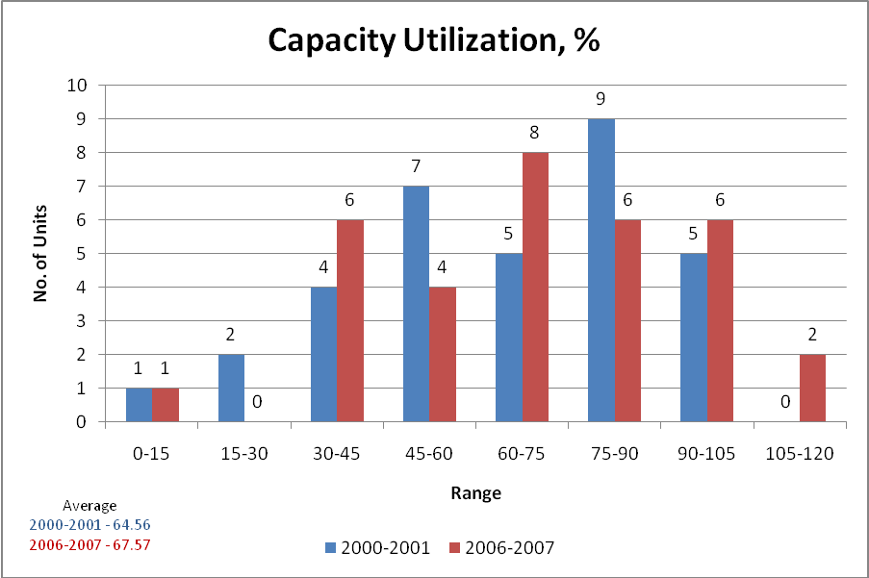

Of the two grain based distilleries, one unit has achieved a capacity utilization of 97.53% and the other unit could attain only 24.93% capacity utilization.
During 2006-2007, the capacity utilization ranged from 4.27% to 111.44% with 03 units recording more than 100%. The average capacity utilization was 67.57% which was an improvement over the 2000-2001 figures of 64.56%. While 18 industries crossed the average capacity utilization of 64.46% in 2000-2001, only 16 could cross this benchmark in 2006-2007.An interesting observation is that the low performers have improved in capacity utilization. In terms of averages there has been an improvement in capacity utilization during the second phase.

(ii) Molasses Consumed
Lower molasses consumption per KL alcohol produced has been regarded as a positive indicator. The industry norm has been taken as 4.87 MT/KL (See Table 1). During the first phase of the study the 33 molasses based distilleries exhibit a range of 4.53-6.28 MT per KL alcohol. Eighteen distilleries were found to be using below this norm of 4.87MT per KL.. The average consumption was 4.97 MT/KL which was higher than the norms. Nineteen distilleries were using below the average leaving 14 distilleries with a scope for improvement at least to average performance.

It has also been estimated for 2000-2001, that the worst performing unit on improving to the best performance is likely to save Rs. 14.00 lacs per annum. An annual saving of Rs. 26.95 crores is estimated if all the units achieve this performance value.

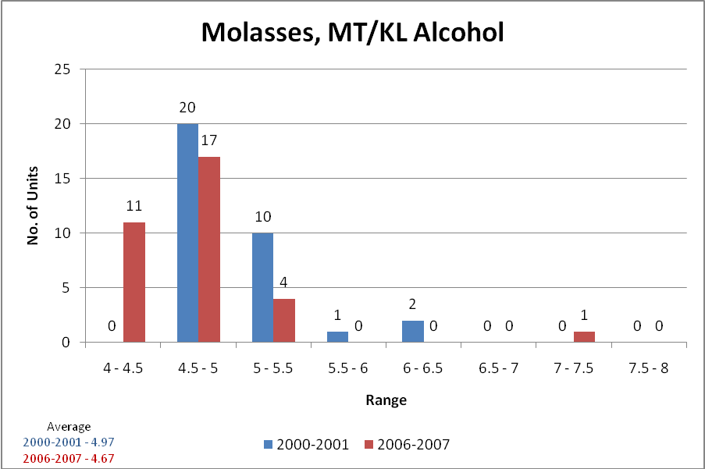

For the year 2006-2007 the consumption of molasses in the 33 molasses based distilleries show a range of 4.02 to 7.12 MT/KL alcohol with an average of 4.67 which is an improvement over the 4.97 MT/KL values for 2000-2001. 19 distilleries in 2000-2001 were using less than 4.97 MT/KL while for the same quantities (4.97) in 2006-2007, 27 industries were below this an improved performance by 08 industries.
In the two grain based distilleries studied the grain consumption was 3.27 and 2.75 MT/KL of alcohol.

(iii) Recovery of Alcohol
The Excise department had laid down a norm of 472.50 liter per MT of TRS for recovery of Alcohol per MT of total reducing sugar in molasses during 2000-2001. The evaluation exercise indicates a wide variation in the actual recovery which ranges from 379.40 to 536.78 Liters/MT of TRS. A lower alcohol recovery has been considered as a negative indicator. The average recovery is 463.73 Liters which is lower than the norms and leaves scope for improvement. Only 14 distilleries perform better than the norms while 21 distilleries are better than the average performance.
The average recoveries for 2006-2007 were 481.76 liters/MT TRS content. Better than the norm of 472.50 and better than the average recovery of 463.73 liters in 2000-2001. In 2006-2007, 24 distilleries were recovering more than the norm as against 14 in 2000-2001 and in terms of improvements over the 2000-2001 average of 463.73, 27 distilleries were recovering more as against 21 earlier.

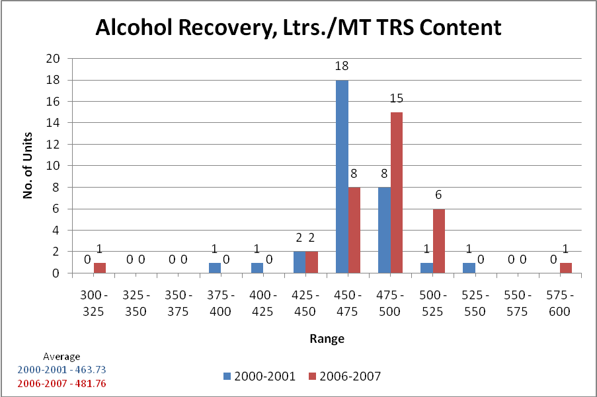

(iv) Water Consumption
Water is an important resource for the industry. The Water (Prevention and Control of Pollution) Cess Act and rules lay down a consumption limit of 15 KL of water per KL of alcohol produced beyond which increased rates of Cess apply. This has been regarded as a norm for the purpose of this exercise.
Ironically only one industry performed better than this norm although proving that it is achievable. It is alarming to note that the average water consumption is as high as 125.22 KL/KL of alcohol. 20 distilleries were consuming less than the average.
While one of the grain based distilleries was using 71.85 KL/KL of alcohol, the other was using 1665.66 KL/KL alcohol. A most shocking revelation.
In terms of water consumption in 2000-2001 it is proved beyond doubt that this is one area where the sector will have to work very hard. It is estimated that the performance improvement by the worst performer by emulating the best would make saving of Rs. 57.50 lacs per annum in its favor. Improvement in water consumption to levels of the best performer is likely to generate an overall saving of Rs. 12.04 crores for the entire sector.
There has been a tremendous improvement in the water consumption per KL alcohol in the year 2006-2007. The average water consumption has come down to 48.9 KL/KL alcohol from the 125.2 KL/KL alcohol in the year 2000-2001. While only 20 industries were equal to or better than the average of 125.2 KL/KL alcohol in 2000-2001, 31 industries achieved these values in 2006-2007. 04 industries were either meeting or almost meeting the norms of 15 KL and 22 industries exhibited an improving trend over the period of the second phase of the study.

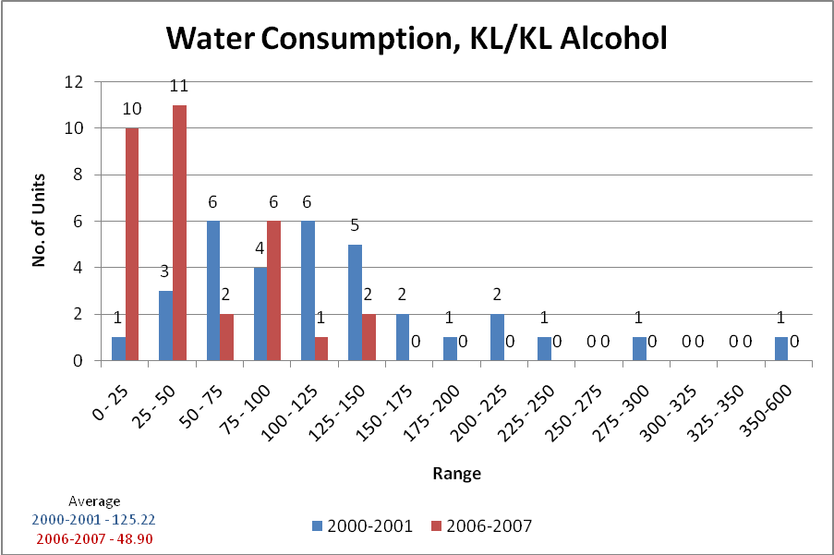

(v) Total Energy Consumption
A lower per unit total energy consumption has been regarded as a positive indicator. In 2000-2001 the average energy consumption was 26.04 GJ/KL of alcohol with a range from 10.17 to 123.56 GJ/KL alcohol. Twenty four units were consuming less than the average and at least 09 were found in the economy range of 10 to 15 GJ/KL alcohol. These have a close chance of learning from the best performer. The worst performer is consuming 123.56 Gj/Kl. If this industry improves to the level of the best performer it will result in a saving of Rs. 3.19 crores per year on 2001 estimates and if the entire industry reduces its consumption to the best level, it would result in a saving of Rs. 45.32 crores.
During the assessment carried out for the years 2004-2005, 2005-2006 and 2006-2007 the average total energy consumption has come down to 24.30 GJ/KL alcohol as against 26.04 for the previous study. Twenty one industries out of 31 assessed for this parameter were better than this average. 10 industries as against 9 earlier were in the economy range of 10 to 15 GJ/KL alcohol . The range has also narrowed down to 5.7 to 114.20 GJ as against 10.17 to 123.56 GJ for 2000-2001.
There has been considerable improvement. With an average production of 430895 KL in 2000-2001 and energy consumption of 11220505 GJ the energy consumption for the same production levels in 2006-2007 has been 10470748.5 GJ, a reduction of 749757 GJ or almost 7%.
Both the grain based distilleries have also improved on this account (Jagatjit Industries 26.641 GJ/KL in 2006-2007 as against 60.64 GJ/KL in 2000-2001 and Radico Khaitan from 79.75 GJ in 2000-2001 to 42.55 GJ in 2006-2007).

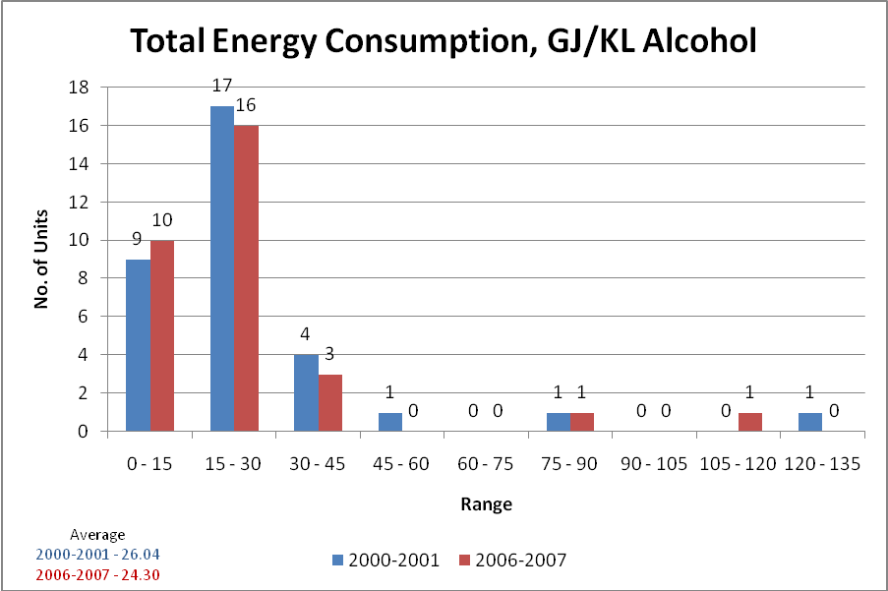

(vi) Renewable Energy as % of Total Energy Consumption
A higher renewable energy component has been considered a positive indicator contributing to better environmental performance. The Renewable energy component has been found to be very significant in 2000-2001 with an average of 79.51% and 24 industries doing better than this and 16 industries doing near 93.42% and better. The grain based distilleries range from 91 to 96%
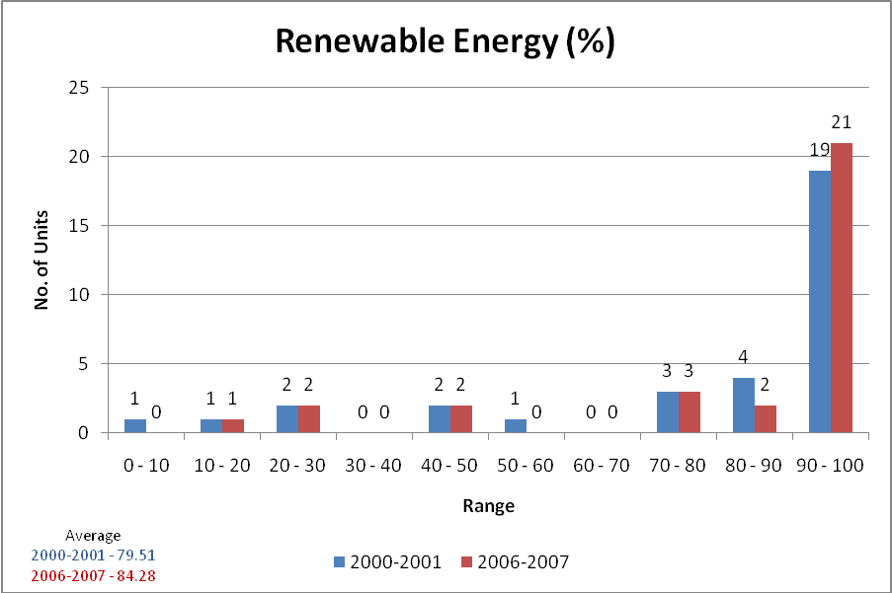

The 2006-2007 evaluation for 31 distilleries as against 33 earlier also shows that the renewable energy component has improved with an average of 84.28% as against 79.51% in 2000-2001 and 19 industries achieving near 93.42% or higher as against 16 earlier.
The grain based distilleries ranges from 90.69 to 99.63 an improvement over previous values.

(vii) External Energy Consumption
The net external energy consumption or the quantity of external fuel used per unit product has also been regarded as an important indicator. It ranges from zero to 123.56 GJ in the 33 molasses based units under evaluation for the year 2000-2001. The average net external energy consumption was 17.70 GJ ( against average Total Energy 26.04 GJ) and 26 distilleries were performing better than this average. 12 industries were performing below 9.44 GJ/KL. The consumption in grain based distilleries is high ranging from 60.64 to 79.75 GJ/KL with an average 70.20 GJ/KL.
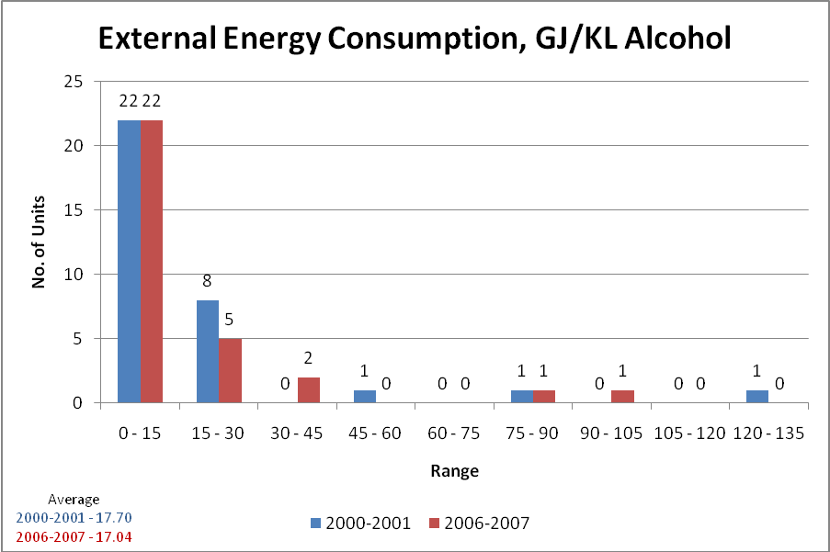

The 2006-2007 evaluation reveals that the average net external energy consumption has come down very slightly from 17.70 GJ to 17.04 GJ with 23 units performing equal to or better than this average and 12 being near 9.44 as earlier.
The net external energy consumption in 03 grain based distilleries range from 24.57 to 106.76 with an average of 58 GJ/KL. This has also registered a decrease from 70.20 GJ/KL in 2000-2001 to 58 GJ/KL in 2006-2007.

(viii) Consent Status
The 2000-2001 assessments reveal that out of a total of 35 distilleries evaluated , 17 molasses based and 2 grain based industries had a valid consent under the Water (Prevention and Control of Pollution) Act 1974 and 16 distilleries did not have a valid consent.
2000

The situation improves in 2006-2007 when 27 molasses based and 03 grain based industries had valid consent and only 06 distilleries were without a valid consent.
2006

This establishes that the voluntary participation in the earlier exercise has achieved significantly more compliance to regulations.

(ix) Marginally/Heavily Polluted Effluents
For THE 2000-2001 assessment, the U.P. Pollution Control Board had agreed upon internal benchmarks for prioritising action against defaulting industries. Under this system a BOD of <200 mg/lt for inland surface water and <500 mg. /lt. for discharge on land classifies as a marginal default while values beyond these classify has major default. The 2000-2001 study identified 22 heavily defaulting units, and 11 marginally defaulting units. 02 industries had achieved zero discharge.

2000-2001

With in the same evaluation criteria, the study results for 2006-2007 indicate only 05 heavy defaulters and 08 marginal defaulters. 23 industries had achieved zero effluent discharge (Biocomposting)
2006-2007

(x) Final disposal of effluents into Stream/Land or conversion into bio-manure
Out of 33 molasses based distilleries under evaluation in 2000-2001, 2 were completely using effluents in bio-manure, 08 were partially using for bio-manure, 03 were discharging on land for ferti-irrigation and 20 units were discharging their total effluents in streams. The grain based distilleries were using the stillage for conversion into cattle feed. Only non process effluents were discharge into stream or land or used for horticulture.
The 2006-2007 study results indicate that 4 units are using treated effluents for ferti-irrigation. 9 are discharging into stream as against 20 earlier and 23 units have achieved zero effluent discharge as against only 02 earlier. This has a potential to considerably reduce pressures on water bodies and land and is a commendable achievement.

2006-2007

(xi) Spent Wash Generated per KL alcohol
The Environment Protection Act 1986 prescribes a standard of 12 KL of Spent wash discharge /KL of alcohol produced. A lower spent wash generated per unit production is an indicator of environmentally sound practices. During the period 2000-2001 the spent wash ranged from 10.87 to 38.34 KL per KL of alcohol produced. The average was 15.48, more than the prescribed norms. 19 industries were observed to be below this average and only 03 with in the norms of 12 KL.

The spent wash generation had reduced considerably during the year 2006-2007 and ranged from 7.89 to 19.56 KL. The average came down to 12.69 KL/KL as against 15.48 earlier. In terms of the average for 2000-2001 where 19 industries were below this average, the number in 2006-2007 has increased to 24,a very positive sign with almost 12 achieving the norms of 12 KL/KL.
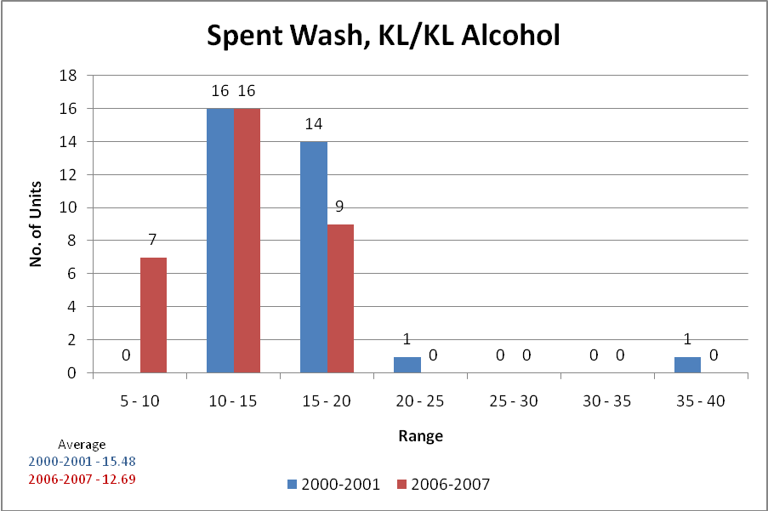

The average stillage generated from the two grain based industries in 2000-2001 is 13.4 KL/KL (range 10.99 to 15.75) while for 2006-2007 the same is observed as 12.26 KL/KL. This also exhibits an improvement.

(xii) Biogas Generation
Production of biogas in primary treatment is an important indicator as more of biogas would mean less of BOD in effluents. Out of the 33 participating industries in 2000-2001, data from 02 was doubtful, biogas plant installed in the distilleries was not found to be functional and biogas from 03 units is discharged into the atmosphere unmonitored and hence the generation could not be measured. Of the remaining 26 industries, the biogas generation ranges from 7.26 to 54.30 Nm³/KL spent wash with an average of 32.31 Nm³/KL. 10 distilleries were producing equal to or more than the average value.
Generation of biogas in grain based distilleries was not observed to be feasible.
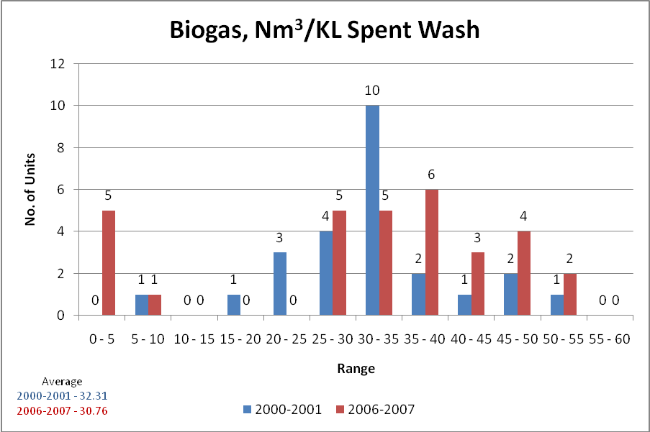

33 distilleries were evaluated in 2006-2007. 02 units were concentrating the spent wash and utilizing it to generate steam and power while achieving zero discharge (India Glycols Limited, Gorakhpur and Bajaj Hindustan Ltd., Saharanpur), 05 units are not utilizing the biogas to meet their energy requirements. They either do not generate biogas or do not utilize it. In the remaining 26 industries the generation of biogas ranges from 9.33 to 54.32 Nm³/KL with an average of 36.67 Nm³/KL, an improvement over 32.31 Nm³/KL recorded earlier.
12 units were generating biogas better than the average values as against 10 earlier. In terms of the earlier average of 32.31 Nm³/KL ………… distilleries are now beyond this as against 10 earlier.
Out of the three grain based distilleries only 01 distillery (Radico Khaitan Ltd.) is generating biogas. The stillage is converted into cattle feed.

(xiii) Dilution Ratio
Dilution of effluents by fresh water or less polluting effluents impacts the effluent discharge from the industry. The lower the dilution ratio, the higher is the pressure on industry to operate the plant more efficiently.
A higher dilution ratio resulting in high water consumption is due mainly to the lower recycling/reuse of effluents in the process and has been considered as a negative indicator. The dilution ratio for 32 distilleries in 2000-2001 ranges from 0.31 to 44.81 with an average of 7.88. 22 distilleries were below the average.
During the year 2006-2007 the exhibited range for the ratio was 0.09 to 15.29 with an average of 3.22, a considerable improvement over the average of 7.88 observed in 2000-2001. Benchmarking with the average of 7.88 in 2000-2001, the study for 2006-2007 revealed that 30 distilleries were below this figure and have improved in terms of using less dilution water.

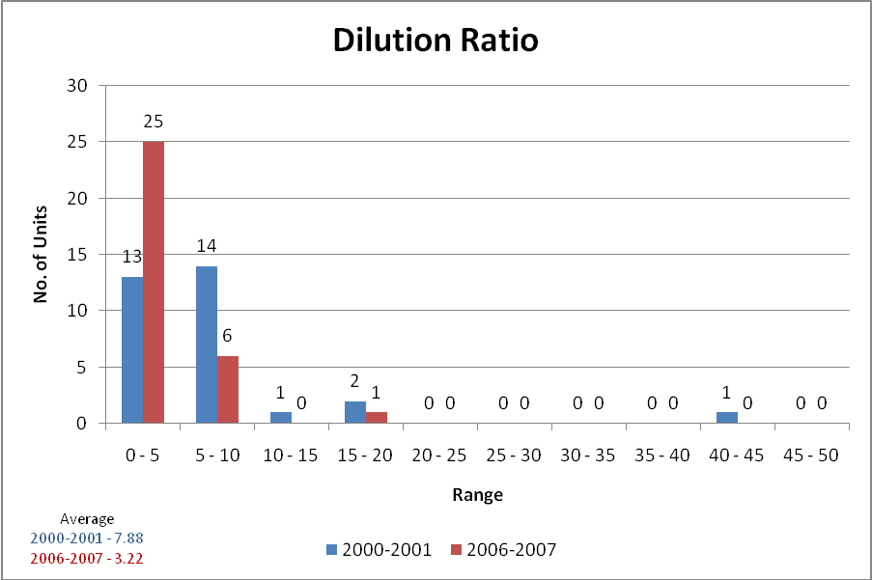

In terms of grain based distilleries, one industry (Whyle and Mackay, India, Rampur) has a dilution ratio of more than 100 which indicated that the industry was producing abnormally high quantity of effluents and wasting water. In 2006-2007 while two grain based distilleries were having low ratios (1.38 and 3.6) the third was very high (79.3) indicating a wastage of water.

(xiv) ISO 14001 Environmental Management System
No unit was observed to be holding an ISO 14001 certification in 2000-2001. In 2006-2007, although a few distilleries were in the process of obtaining the ISO certification, there is no distillery having the certificate.

(xv) Overall performance
In terms of the overall performance score based on all the parameters, the 2000-2001 study revealed a range of 1.82 to 54.15 and an average score of 26.27. 15 distilleries were equaling to or better than this average.
The range for overall environmental performance for the study in 2006-2007 indicates a range of 14 to 78 with an average performance of 48.71. This is a considerable improvement over the past performance of 2000-2001.
Comparing to the 2000-2001 average marks of 26.27 when 15 distilleries were equal to or better than the score, the study for 2006-2007 has revealed that 30 distilleries have improved on this performance benchmark.

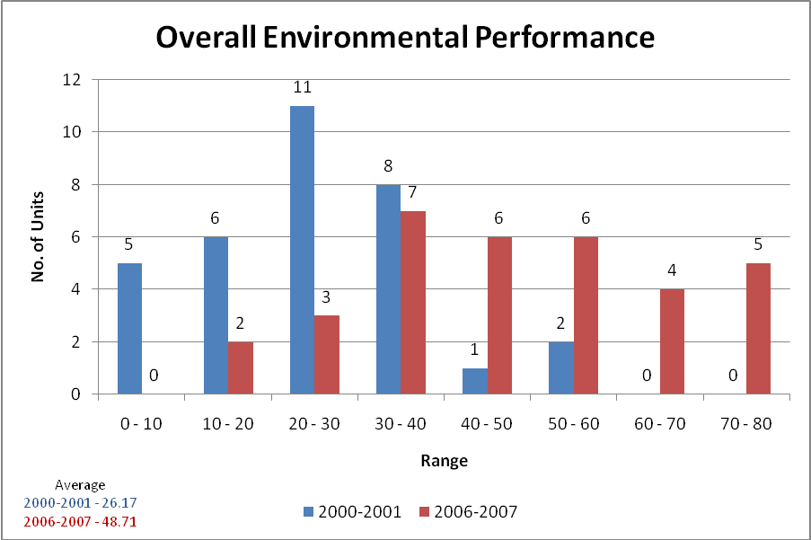

The average for 2006-2007 (48.71) is almost close to the best performer of 2000-2001 (54.15) and 12 distilleries have performed better than the best performer of 2000-2001. This is good achievement.
The grain based distilleries have also improved (42 and 54 in 2000-2001 to 42, 43 and 75 in 2006-2007)

Conclusions
The study for the period 2000-2001 had indicated the following:
1. Distilleries in central and western U.P. are marginally better performers.
2. The semi urban distilleries were observed to perform better than the urban and rural based units.
3. 57% distilleries are located in the Ganga catchment followed by Ghagra and Yamuna. 86% of the distilleries discharge their effluents into the rivers (Ghagra-5, Gomti-1, Ganga-18 and Yamuna-6)
4. An improved environmental performance leads to better profitability.
5. The sector is not sensitive to the efficient use of raw materials, water, fuel and power. Optimization in raw material consumption and judicious use of water and energy shall reduce the production cost and increase profitability. This will make the product more competitive in the Global market and help the industry to maximize the capacity utilization.
6. If the bad performers evaluate the best performers, the sector is likely to save Rs. 105.81 Crores by optimizing resource utilization (Molasses Rs. 26.95 Crores, Water Rs. 12.04 Crores, Biogas Rs. 22.50 Crores, Total Energy Rs. 45.32 Crores)

The following recommendations were made and presented before an open house session with Industry representatives and the Pollution Control Board.
1. Eighteen out of the 33 units studied have a very poor environmental performance.
2. All plants should have facilities to monitor the amount of biogas generated. They must also ensure to utilize the gas in boilers to meet the energy requirements. Where the biogas generation is poor, industries should retrofit the inefficient plants.
3. Those units which have not installed the second aerobic stage should do it at the earliest.
4. There is immense scope for reducing water consumption. This should be implemented.
5. Metering systems should be installed to monitor consumption of biogas, water and electricity.
6. Wherever feasible effluents should be utilized in production of bio-manure or in the case of grain based distilleries as cattle feed. Use of treated effluents for irrigation should be encouraged.
7. Energy audit and trainings should be utilized
8. Best available technologies should be utilized.
9. Distilleries should be encouraged to implement ISO 14001.
Against these findings and recommendations these has been a considerable improvement in environmental performance in 2006-2007. 24 distilleries were common to both the phases of the study, 22 of these have improved by way of total environmental performance, 12 in terms of capacity utilization, 18 in terms of molasses consumption, 17 in terms of average recovery of alcohol, 18 in terms of water consumption, 10 (out 0f 22) in terms of total energy consumption, 14 (out of 22) in terms of total renewable energy consumption, 17 (out of 22) in terms of spent wash generation, 13 (out of 19) in terms of biogas generation, 18 (out of 22) in terms of dilution ratio.(Tables 2 to 10.
The repeat study has also reiterated the findings of the earlier study that an improved environmental performance leads to better profitability. There has been a considerable improvement in per capita use of resources although there is still scope for improvement. Two industries have adopted technologies based on concentration of spent wash and burning the same in better to generate steam and power for the process. These units show improved performance on all the energy indicators and have no effluent issues. Some new units installed in 2006-2007 or later are based on this technology.

The overall performance of distilleries has shown substantial improvement. There has also been a 89% reduction in the discharge of BOD from the distilleries (4637.86 MT per year in 200-2001 to 517.70 MT per year in 2006-2007).

Significantly also disposal of B.O.D into streams has come down by 97.75 %( 4526.55 Mt/year in 2000-01 to 102.02 MT/year in 2006-07). Land disposal has slightly increased from 111.31 MT/Year to 415.68 MT/year. In terms of BOD discharged per KL alcohol production the values have come down from 12.45 KG/KL alcohol to 1.72 KG/KL alcohol. A reduction of about 86%.
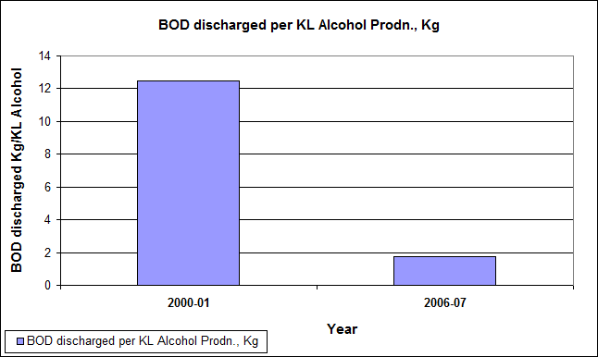

Annexure-15
Environmental Performance (2006-07) of the Distilleries compared to 2000-01

Comparative analysis of performance of distilleries in the year 2000-01 & 2006-07

Molasses Based Distilleries
Sl. | Distillery | Total Marks (%)  (2000-01) | Total Marks (%)  (2006-07) | Variation (%)
1 | The Kisan Sahkari Chini Mills Ltd. Distillery Unit, Kaimganj (Farrukhabad) | 1.514 | 15.029 | 89.93
2 | Nanauta Distillery Unit, Nanauta, Saharanpur | 3.845 | 37.244 | 89.68
3 | Kisan Sahkari Chini Mills Ltd., Ghosi - Mau | 6.257 | 47.767 | 86.90
4 | Modi Distillery (A Unit of Modi Industries Ltd.) | 10.208 | 58.433 | 82.53
5 | UP Co-operative Sugar Factories Federation Ltd., Anoop Shahar, Bulandshahar | 8.445 | 27.792 | 69.61
6 | Kesar Enterprises Ltd., Baheri, Bareilly | 23.665 | 51.695 | 54.22
7 | Mohan Meakin Ltd. Lucknow | 16.049 | 31.857 | 49.62
8 | Balrampur Chini Mills Ltd. (Chemical Division) Balrampur | 29.728 | 55.585 | 46.52
9 | Bajaj Hindustan Ltd. Unit Distillery | 38.758 | 68.467 | 43.39
10 | Daurala Sugar Works, Meerut | 21.858 | 38.110 | 42.65
11 | The Dhampur Sugar Mills Ltd. Unit: D.S.M. Chemicals | 37.523 | 65.140 | 42.40
12 | The Oudh Sugar Mills Ltd. (Distillery Division) | 36.659 | 63.443 | 42.22
13 | UGSIL Ltd. Distillery Unit | 28.151 | 47.921 | 41.26
14 | Lords Distillery Limited, Ghazipur | 27.444 | 45.854 | 40.15
15 | National Industrial Corporation Limited, Raja-Ka-Sahaspur | 22.120 | 35.349 | 37.42
16 | Simbhaoli Sugars Limited, Unit: Simbhaoli Distillery | 50.667 | 74.360 | 31.86
17 | Jubliant Organosys Ltd. | 54.153 | 72.935 | 25.75
18 | Mohan Nagar Distillery, Mohan Meakin Ltd. | 24.528 | 31.953 | 23.24
19 | Rampur Distillery, Rampur | 39.460 | 49.671 | 20.56
20 | Narang Distillery Limited, Gonda | 23.943 | 28.053 | 14.65
21 | Unnao Distilleries and Breweries Ltd., Unnao | 36.278 | 39.688 | 8.59
22 | Pilkhani Distillery & Chemical Works, Saharanpur | 35.182 | 38.170 | 7.83
23 | K.M. Sugar Mills Ltd., Faizabad | 26.070 | 22.753 | -14.58
24 | Majhola Distillery & Chemical Works, Majhola Distt-Pilibhit (U.P.) | 18.258 | 14.234 | -28.27
 | AVERAGE | 25.865 | 44.229 | 41.52
Grain Based Distilleries
Sl. | Distillery | Total Marks (%)  (2000-01) | Total Marks (%)  (2006-07) | Variation (%)
1 | Jagatjit Industries Limited, Sikandarabad | 54.000 | 42.960 | -25.70
2 | Whyte & Mackay (India) - now Radico Khaitan - Unit MSP | 42.000 | 41.460 | -1.30
 | AVERAGE | 48.000 | 42.210 | -13.72

Annexure-16
Environmental Performance of Alcohol Distilleries

Comparative analysis of performance of distilleries in the year 2000-01 & 2006-07
Sl. | Name of Distillery | Capacity Utilisation (%) |  | %age Variation over 2000-01
Sl. | Name of Distillery | 2000-01 | 2006-07 | %age Variation over 2000-01
1 | National Industrial Corporation Limited, Raja-Ka-Sahaspur | 53.747 | 31.348 | -41.68
2 | Modi Distillery (A Unit of Modi Industries Ltd.) | 65.804 | 90.930 | 38.18
3 | Mohan Nagar Distillery, Mohan Meakin Ltd. | 76.612 | 4.272 | -94.42
4 | The Oudh Sugar Mills Ltd. (Distillery Division) | 53.327 | 75.656 | 41.87
5 | UGSIL Ltd. Distillery Unit | 72.369 | 74.995 | 3.63
6 | Balrampur Chini Mills Ltd. (Chemical Division) Balrampur | 78.751 | 60.119 | -23.66
7 | Daurala Sugar Works, Meerut | 46.523 | 41.991 | -9.74
8 | Rampur Distillery, Rampur | 103.822 | 100.290 | -3.40
9 | Pilkhani Distillery & Chemical Works | 81.300 | 63.950 | -21.34
10 | Mohan Meakin Ltd. Lucknow | 77.343 | 89.050 | 15.14
11 | The Dhampur Sugar Mills Ltd. Unit: D.S.M. Chemicals | 49.053 | 81.481 | 66.11
12 | Kesar Enterprises Ltd., Baheri, Bareilly | 89.669 | 109.189 | 21.77
13 | Nanauta Distillery Unit, Nanauta, Saharanpur | 40.955 | 59.284 | 44.75
14 | The Kisan Sahkari Chini Mills Ltd. Distillery Unit, Kaimganj (Farrukhabad) | 2.896 | 37.465 | 1193.68
15 | UP Co-operative Sugar Factories Federation Ltd. | 50.442 | 34.267 | -32.07
16 | Majhola Distillery & Chemical Works, Majhola Distt-Pilibhit (U.P.) | 84.548 | 69.293 | -18.04
17 | Bajaj Hindustan Ltd. Unit Distillery | 36.905 | 61.248 | 65.96
18 | Simbhaoli Sugars Limited, Unit: Simbhaoli Distillery | 92.249 | 90.473 | -1.92
19 | Jubliant Organosys Ltd. | 84.316 | 91.166 | 8.12
20 | Kisan Sahkari Chini Mills Ltd., Ghosi - Mau | 27.908 | 51.004 | 82.76
21 | Lords Distillery Limited, Ghazipur | 29.376 | 58.160 | 97.99
22 | K.M. Sugar Mills Ltd., Faizabad | 67.542 | 64.343 | -4.74
23 | Unnao Distilleries and Breweries Ltd., Unnao | 105.146 | 99.791 | -5.09
24 | Narang Distillery Limited, Gonda | 71.975 | 31.980 | -55.57
 | Minimum | 2.896 | 4.272 | 47.514
 | Maximum | 105.146 | 109.189 | 3.844
 | Average | 64.274 | 65.489 | 1.891
No. of Distilleries improved - 12
No. of Distilleries declined - 12
Annexure-17
Environmental Performance of Alcohol Distilleries

Comparative analysis of performance of distilleries in the year 2000-01 & 2006-07

Sl. | Name of Distillery | Consumption of Molasses MT/ KL production of Alcohol |  | Remarks
Sl. | Name of Distillery | 2000-01 | 2006-07 | Remarks
1 | National Industrial Corporation Limited, Raja-Ka-Sahaspur | 5.012 | 7.122 | -42.11
2 | Modi Distillery (A Unit of Modi Industries Ltd.) | 5.111 | 4.483 | 12.29
3 | Mohan Nagar Distillery, Mohan Meakin Ltd. | 4.774 | 4.947 | -3.63
4 | The Oudh Sugar Mills Ltd. (Distillery Division) | 4.756 | 4.579 | 3.72
5 | UGSIL Ltd. Distillery Unit | 4.828 | 4.604 | 4.65
6 | Balrampur Chini Mills Ltd. (Chemical Division) Balrampur | 4.534 | 4.601 | -1.47
7 | Daurala Sugar Works, Meerut | 4.959 | 4.744 | 4.34
8 | Rampur Distillery, Rampur | 4.787 | 4.523 | 5.50
9 | Pilkhani Distillery & Chemical Works | 4.688 | 4.732 | -0.93
10 | Mohan Meakin Ltd. Lucknow | 5.593 | 5.076 | 9.25
11 | The Dhampur Sugar Mills Ltd. Unit: D.S.M. Chemicals | 5.164 | 4.587 | 11.16
12 | Kesar Enterprises Ltd., Baheri, Bareilly | 5.017 | 4.563 | 9.05
13 | Nanauta Distillery Unit, Nanauta, Saharanpur | 4.622 | 4.521 | 2.17
14 | The Kisan Sahkari Chini Mills Ltd. Distillery Unit, Kaimganj (Farrukhabad) | 6.276 | 4.446 | 29.16
15 | UP Co-operative Sugar Factories Federation Ltd. | 5.069 | 4.728 | 6.73
16 | Majhola Distillery & Chemical Works, Majhola Distt-Pilibhit (U.P.) | 4.744 | 4.456 | 6.08
17 | Bajaj Hindustan Ltd. Unit Distillery | 4.572 | 4.654 | -1.81
18 | Simbhaoli Sugars Limited, Unit: Simbhaoli Distillery | 4.811 | 4.357 | 9.45
19 | Jubliant Organosys Ltd. | 5.024 | 4.798 | 4.50
20 | Kisan Sahkari Chini Mills Ltd., Ghosi - Mau | 4.634 | 4.219 | 8.95
21 | Lords Distillery Limited, Ghazipur | 4.871 | 5.187 | -6.49
22 | K.M. Sugar Mills Ltd., Faizabad | 5.062 | 4.772 | 5.73
23 | Unnao Distilleries and Breweries Ltd., Unnao | 4.627 | 4.025 | 13.02
24 | Narang Distillery Limited, Gonda | 5.389 | 5.033 | 6.62
 | Minimum | 4.534 | 4.025 | 11.22
 | Maximum | 6.276 | 7.122 | -13.49
 | Average | 4.955 | 4.740 | 4.34

No. of Distilleries improved - 18
No. of Distilleries declined - 06
Annexure-18
Environmental Performance of Alcohol Distilleries

Comparative analysis of performance of distilleries in the year 2000-01 & 2006-07

Sl. | Name of Distillery | Recovery of Alcohol per Metric Ton of TRS in Molasses (Litre) |  | Remarks
Sl. | Name of Distillery | 2000-01 | 2006-07 | Remarks
1 | National Industrial Corporation Limited, Raja-Ka-Sahaspur | 462.972 | 323.535 | -30.12
2 | Modi Distillery (A Unit of Modi Industries Ltd.) | 435.726 | 478.631 | 9.85
3 | Mohan Nagar Distillery, Mohan Meakin Ltd. | 479.867 | 472.253 | -1.59
4 | The Oudh Sugar Mills Ltd. (Distillery Division) | 477.719 | 486.458 | 1.83
5 | UGSIL Ltd. Distillery Unit | 477.466 | 489.783 | 2.58
6 | Balrampur Chini Mills Ltd. (Chemical Division) Balrampur | 509.285 | 502.000 | -1.43
7 | Daurala Sugar Works, Meerut | 469.267 | 473.077 | 0.81
8 | Rampur Distillery, Rampur | 490.273 | 495.672 | 1.10
9 | Pilkhani Distillery & Chemical Works | 472.608 | 476.904 | 0.91
10 | Mohan Meakin Ltd. Lucknow | 402.607 | 463.581 | 15.14
11 | The Dhampur Sugar Mills Ltd. Unit: D.S.M. Chemicals | 454.480 | 486.584 | 7.06
12 | Kesar Enterprises Ltd., Baheri, Bareilly | 475.603 | 492.727 | 3.60
13 | Nanauta Distillery Unit, Nanauta, Saharanpur | 474.401 | 469.568 | -1.02
14 | The Kisan Sahkari Chini Mills Ltd. Distillery Unit, Kaimganj (Farrukhabad) | 379.404 | 496.541 | 30.87
15 | UP Co-operative Sugar Factories Federation Ltd. | 450.200 | 461.410 | 2.49
16 | Majhola Distillery & Chemical Works, Majhola Distt-Pilibhit (U.P.) | 536.778 | 487.900 | -9.11
17 | Bajaj Hindustan Ltd. Unit Distillery | 483.944 | 503.418 | 4.02
18 | Simbhaoli Sugars Limited, Unit: Simbhaoli Distillery | 465.099 | 488.376 | 5.00
19 | Jubliant Organosys Ltd. | 470.983 | 484.696 | 2.91
20 | Kisan Sahkari Chini Mills Ltd., Ghosi - Mau | 474.001 | 491.752 | 3.74
21 | Lords Distillery Limited, Ghazipur | 462.626 | 458.921 | -0.80
22 | K.M. Sugar Mills Ltd., Faizabad | 451.531 | 476.232 | 5.47
23 | Unnao Distilleries and Breweries Ltd., Unnao | 474.335 | 575.121 | 21.25
24 | Narang Distillery Limited, Gonda | 460.301 | 459.959 | -0.07
 | Minimum | 379.404 | 323.535 | -14.73
 | Maximum | 536.778 | 575.121 | 7.14
 | Average | 466.311 | 478.962 | 2.71

No. of Distilleries improved - 17
No. of Distilleries declined - 07
Annexure-19
Environmental Performance of Alcohol Distilleries

Comparative analysis of performance of distilleries in the year 2000-01 & 2006-07

Sl. | Name of Distillery | Water consumption per Kilolitre production of Alcohol (KL) |  | Remarks
Sl. | Name of Distillery | 2000-01 | 2006-07 | Remarks
1 | National Industrial Corporation Limited, Raja-Ka-Sahaspur | 104.671 | 15.015 | 85.66
2 | Modi Distillery (A Unit of Modi Industries Ltd.) | 205.497 | 52.205 | 74.60
3 | Mohan Nagar Distillery, Mohan Meakin Ltd. | 52.106 | 17.116 | 67.15
4 | The Oudh Sugar Mills Ltd. (Distillery Division) | 127.498 | 13.864 | 89.13
5 | UGSIL Ltd. Distillery Unit | 111.539 | 130.106 | -16.65
6 | Balrampur Chini Mills Ltd. (Chemical Division) Balrampur | 102.339 | 37.348 | 63.51
7 | Daurala Sugar Works, Meerut | 283.793 | 92.409 | 67.44
8 | Rampur Distillery, Rampur | 64.952 | 30.654 | 52.80
9 | Pilkhani Distillery & Chemical Works | 78.473 | 42.359 | 46.02
10 | Mohan Meakin Ltd. Lucknow | 135.325 | 38.686 | 71.41
11 | The Dhampur Sugar Mills Ltd. Unit: D.S.M. Chemicals | 237.836 | 19.028 | 92.00
12 | Kesar Enterprises Ltd., Baheri, Bareilly | 145.610 | 108.149 | 25.73
13 | Nanauta Distillery Unit, Nanauta, Saharanpur | 70.000 | 95.987 | -37.12
14 | The Kisan Sahkari Chini Mills Ltd. Distillery Unit, Kaimganj (Farrukhabad) | 136.490 | 84.043 | 38.43
15 | UP Co-operative Sugar Factories Federation Ltd. | 84.211 | 84.935 | -0.86
16 | Majhola Distillery & Chemical Works, Majhola Distt-Pilibhit (U.P.) | 110.360 | 135.507 | -22.79
17 | Bajaj Hindustan Ltd. Unit Distillery | 137.507 | 17.538 | 87.25
18 | Simbhaoli Sugars Limited, Unit: Simbhaoli Distillery | 32.606 | 18.198 | 44.19
19 | Jubliant Organosys Ltd. | 14.689 | 15.702 | -6.90
20 | Kisan Sahkari Chini Mills Ltd., Ghosi - Mau | 167.726 | 39.872 | 76.23
21 | Lords Distillery Limited, Ghazipur | 107.986 | 36.945 | 65.79
22 | K.M. Sugar Mills Ltd., Faizabad | 52.399 | 26.551 | 49.33
23 | Unnao Distilleries and Breweries Ltd., Unnao | 51.531 | 32.529 | 36.88
24 | Narang Distillery Limited, Gonda | 82.106 | 87.997 | -7.17
 | Minimum | 14.689 | 13.864 | 5.61
 | Maximum | 283.793 | 135.507 | 52.25
 | Average | 112.385 | 53.031 | 52.81

No. of Distilleries improved - 18
No. of Distilleries declined - 06
Annexure-20
Environmental Performance of Alcohol Distilleries

Comparative analysis of performance of distilleries in the year 2000-01 & 2006-07

Sl. | Name of Distillery | Total Energy Consumption per Kilolitre production of Alcohol (GJ) |  | Remarks
Sl. | Name of Distillery | 2000-01 | 2006-07 | Remarks
1 | National Industrial Corporation Limited, Raja-Ka-Sahaspur | 26.463 | 12.933 | 51.13
2 | Modi Distillery (A Unit of Modi Industries Ltd.) | 26.698 | 13.354 | 49.98
3 | Mohan Nagar Distillery, Mohan Meakin Ltd. | 31.556 | 23.455 | 25.67
4 | The Oudh Sugar Mills Ltd. (Distillery Division) | 33.972 | 31.296 | 7.88
5 | UGSIL Ltd. Distillery Unit | 21.093 | 114.201 | -441.42
6 | Balrampur Chini Mills Ltd. (Chemical Division) Balrampur | 20.697 | 17.460 | 15.64
7 | Daurala Sugar Works, Meerut | 13.332 | 20.429 | -53.23
8 | Rampur Distillery, Rampur | 14.781 | 13.494 | 8.70
9 | Pilkhani Distillery & Chemical Works | 16.745 | 20.082 | -19.92
10 | Mohan Meakin Ltd. Lucknow | 24.574 | 26.642 | -8.41
11 | The Dhampur Sugar Mills Ltd. Unit: D.S.M. Chemicals | 31.254 | 21.760 | 30.38
12 | Kesar Enterprises Ltd., Baheri, Bareilly | 13.963 | 15.281 | -9.44
13 | Nanauta Distillery Unit, Nanauta, Saharanpur | 17.575 | 5.821 | 66.88
14 | The Kisan Sahkari Chini Mills Ltd. Distillery Unit, Kaimganj (Farrukhabad)
15 | UP Co-operative Sugar Factories Federation Ltd. | 15.700 | 78.202 | -398.10
16 | Majhola Distillery & Chemical Works, Majhola Distt-Pilibhit (U.P.) | 19.030 | 23.528 | -23.64
17 | Bajaj Hindustan Ltd. Unit Distillery | 19.251 | 24.978 | -29.75
18 | Simbhaoli Sugars Limited, Unit: Simbhaoli Distillery | 10.166 | 20.895 | -105.53
19 | Jubliant Organosys Ltd. | 14.345 | 16.038 | -11.80
20 | Kisan Sahkari Chini Mills Ltd., Ghosi - Mau | 123.558 | 11.299 | 90.86
21 | Lords Distillery Limited, Ghazipur | 17.274 | 25.555 | -47.94
22 | K.M. Sugar Mills Ltd., Faizabad
23 | Unnao Distilleries and Breweries Ltd., Unnao | 15.179 | 11.447 | 24.59
24 | Narang Distillery Limited, Gonda | 21.416 | 27.116 | -26.61
 | Minimum | 10.166 | 5.821 | 42.74
 | Maximum | 123.558 | 114.201 | 7.57
 | Average | 24.937 | 26.148 | -4.86

No. of Distilleries improved - 10
No. of Distilleries declined - 12
Annexure-21
Environmental Performance of Alcohol Distilleries

Comparative analysis of performance of distilleries in the year 2000-01 & 2006-07

Sl. | Name of Distillery | Total Renewable Energy (in terms of % of Total Energy) |  | Remarks
Sl. | Name of Distillery | 2000-01 | 2006-07 | Remarks
1 | National Industrial Corporation Limited, Raja-Ka-Sahaspur | 96.648 | 98.245 | 1.65
2 | Modi Distillery (A Unit of Modi Industries Ltd.) | 91.380 | 100.000 | 9.43
3 | Mohan Nagar Distillery, Mohan Meakin Ltd. | 44.180 | 48.191 | 9.08
4 | The Oudh Sugar Mills Ltd. (Distillery Division) | 95.384 | 98.947 | 3.74
5 | UGSIL Ltd. Distillery Unit | 96.635 | 27.672 | -71.36
6 | Balrampur Chini Mills Ltd. (Chemical Division) Balrampur | 99.198 | 99.778 | 0.59
7 | Daurala Sugar Works, Meerut | 52.200 | 97.621 | 87.01
8 | Rampur Distillery, Rampur | 98.099 | 97.597 | -0.51
9 | Pilkhani Distillery & Chemical Works | 79.925 | 83.293 | 4.21
10 | Mohan Meakin Ltd. Lucknow | 41.158 | 46.709 | 13.49
11 | The Dhampur Sugar Mills Ltd. Unit: D.S.M. Chemicals | 100.000 | 100.000 | 0.00
12 | Kesar Enterprises Ltd., Baheri, Bareilly | 91.666 | 98.585 | 7.55
13 | Nanauta Distillery Unit, Nanauta, Saharanpur | 96.575 | 100.000 | 3.55
14 | The Kisan Sahkari Chini Mills Ltd. Distillery Unit, Kaimganj (Farrukhabad)
15 | UP Co-operative Sugar Factories Federation Ltd. | 94.921 | 19.070 | -79.91
16 | Majhola Distillery & Chemical Works, Majhola Distt-Pilibhit (U.P.) | 95.067 | 94.351 | -0.75
17 | Bajaj Hindustan Ltd. Unit Distillery | 99.656 | 93.887 | -5.79
18 | Simbhaoli Sugars Limited, Unit: Simbhaoli Distillery | 88.881 | 96.770 | 8.88
19 | Jubliant Organosys Ltd. | 100.000 | 73.218 | -26.78
20 | Kisan Sahkari Chini Mills Ltd., Ghosi - Mau | 98.505 | 97.764 | -0.75
21 | Lords Distillery Limited, Ghazipur | 76.739 | 84.531 | 10.15
22 | K.M. Sugar Mills Ltd., Faizabad
23 | Unnao Distilleries and Breweries Ltd., Unnao | 25.588 | 73.299 | 186.46
24 | Narang Distillery Limited, Gonda | 100.000 | 92.033 | -7.97
 | Minimum | 25.588 | 19.070 | -25.47
 | Maximum | 100.000 | 100.000 | 0.00
 | Average | 84.655 | 82.798 | -2.19

No. of Distilleries improved - 14
No. of Distilleries declined - 08
Annexure-22
Environmental Performance of Alcohol Distilleries

Comparative analysis of performance of distilleries in the year 2000-01 & 2006-07

Sl. | Name of Distillery | Net External Energy consumption per Kilolitre production of Alcohol (GJ) |  | Remarks
Sl. | Name of Distillery | 2000-01 | 2006-07 | Remarks
1 | National Industrial Corporation Limited, Raja-Ka-Sahaspur | 13.769 | 12.548 | 8.87
2 | Modi Distillery (A Unit of Modi Industries Ltd.) | 17.628 | 6.274 | 64.41
3 | Mohan Nagar Distillery, Mohan Meakin Ltd. | 17.614 | 12.152 | 31.01
4 | The Oudh Sugar Mills Ltd. (Distillery Division) | 20.773 | 19.539 | 5.94
5 | UGSIL Ltd. Distillery Unit | 12.739 | 102.007 | -700.74
6 | Balrampur Chini Mills Ltd. (Chemical Division) Balrampur | 11.806 | 10.628 | 9.98
7 | Daurala Sugar Works, Meerut | 6.373 | 8.246 | -29.40
8 | Rampur Distillery, Rampur | 3.264 | 1.000 | 69.36
9 | Pilkhani Distillery & Chemical Works | 8.844 | 8.715 | 1.46
10 | Mohan Meakin Ltd. Lucknow | 14.460 | 14.198 | 1.81
11 | The Dhampur Sugar Mills Ltd. Unit: D.S.M. Chemicals | 19.688 | 13.234 | 32.78
12 | Kesar Enterprises Ltd., Baheri, Bareilly | 5.812 | 6.967 | -19.87
13 | Nanauta Distillery Unit, Nanauta, Saharanpur | 17.575 | 5.821 | 66.88
14 | The Kisan Sahkari Chini Mills Ltd. Distillery Unit, Kaimganj (Farrukhabad)
15 | UP Co-operative Sugar Factories Federation Ltd. | 15.700 | 78.202 | -398.10
16 | Majhola Distillery & Chemical Works, Majhola Distt-Pilibhit (U.P.) | 13.055 | 16.732 | -28.16
17 | Bajaj Hindustan Ltd. Unit Distillery | 12.264 | 12.309 | -0.37
18 | Simbhaoli Sugars Limited, Unit: Simbhaoli Distillery | 1.130 | 12.203 | -979.57
19 | Jubliant Organosys Ltd. | 0.000 | 4.295
20 | Kisan Sahkari Chini Mills Ltd., Ghosi - Mau | 123.558 | 11.299 | 90.86
21 | Lords Distillery Limited, Ghazipur | 8.522 | 8.210 | 3.66
22 | K.M. Sugar Mills Ltd., Faizabad
23 | Unnao Distilleries and Breweries Ltd., Unnao | 11.295 | 3.093 | 72.61
24 | Narang Distillery Limited, Gonda | 10.037 | 17.529 | -74.64
 | Minimum | 0.000 | 1.000
 | Maximum | 123.558 | 102.007 | 17.44
 | Average | 16.632 | 17.509 | -5.27

No. of Distilleries improved - 13
No. of Distilleries declined - 09
Annexure-23
Environmental Performance of Alcohol Distilleries

Comparative analysis of performance of distilleries in the year 2000-01 & 2006-07

Sl. | Name of Distillery | Quantity of Spent Wash generated per Kilolitre production of Alcohol (KL) |  | Remarks
Sl. | Name of Distillery | 2000-01 | 2006-07 | Remarks
1 | National Industrial Corporation Limited, Raja-Ka-Sahaspur | 16.126 | 15.015 | 6.89
2 | Modi Distillery (A Unit of Modi Industries Ltd.) | 15.692 | 9.239 | 41.12
3 | Mohan Nagar Distillery, Mohan Meakin Ltd. | 20.577 | 19.561 | 4.94
4 | The Oudh Sugar Mills Ltd. (Distillery Division) | 13.851 | 13.622 | 1.66
5 | UGSIL Ltd. Distillery Unit | 12.658 | 8.220 | 35.06
6 | Balrampur Chini Mills Ltd. (Chemical Division) Balrampur | 12.649 | 8.957 | 29.19
7 | Daurala Sugar Works, Meerut | 14.390 | 15.945 | -10.81
8 | Rampur Distillery, Rampur | 12.659 | 10.987 | 13.21
9 | Pilkhani Distillery & Chemical Works | 14.893 | 12.636 | 15.15
10 | Mohan Meakin Ltd. Lucknow | 16.824 | 13.500 | 19.76
11 | The Dhampur Sugar Mills Ltd. Unit: D.S.M. Chemicals | 11.359 | 12.684 | -11.67
12 | Kesar Enterprises Ltd., Baheri, Bareilly | 13.189 | 13.230 | -0.31
13 | Nanauta Distillery Unit, Nanauta, Saharanpur
14 | The Kisan Sahkari Chini Mills Ltd. Distillery Unit, Kaimganj (Farrukhabad)
15 | UP Co-operative Sugar Factories Federation Ltd. | 16.134 | 15.925 | 1.29
16 | Majhola Distillery & Chemical Works, Majhola Distt-Pilibhit (U.P.) | 15.049 | 12.756 | 15.23
17 | Bajaj Hindustan Ltd. Unit Distillery | 15.737 | 12.249 | 22.17
18 | Simbhaoli Sugars Limited, Unit: Simbhaoli Distillery | 14.130 | 12.087 | 14.46
19 | Jubliant Organosys Ltd. | 13.918 | 13.000 | 6.59
20 | Kisan Sahkari Chini Mills Ltd., Ghosi - Mau | 16.000 | 15.904 | 0.60
21 | Lords Distillery Limited, Ghazipur | 15.156 | 12.001 | 20.82
22 | K.M. Sugar Mills Ltd., Faizabad | 11.934 | 14.542 | -21.85
23 | Unnao Distilleries and Breweries Ltd., Unnao | 16.096 | 15.863 | 1.45
24 | Narang Distillery Limited, Gonda | 14.894 | 17.846 | -19.83
 | Minimum | 11.359 | 8.220 | 27.63
 | Maximum | 20.577 | 19.561 | 4.94
 | Average | 14.723 | 13.444 | 8.69

No. of Distilleries improved - 17
No. of Distilleries declined - 05
Annexure-24
Environmental Performance of Alcohol Distilleries

Comparative analysis of performance of distilleries in the year 2000-01 & 2006-07

Sl. | Name of Distillery | Biogas generated per Kilolitre of Spent Wash |  | Remarks
Sl. | Name of Distillery | 2000-01 | 2006-07 | Remarks
1 | National Industrial Corporation Limited, Raja-Ka-Sahaspur | 37.573 | 36.000 | -4.19
2 | Modi Distillery (A Unit of Modi Industries Ltd.) | 29.252 | 38.350 | 31.10
3 | Mohan Nagar Distillery, Mohan Meakin Ltd. | 33.000 | 27.582 | -16.42
4 | The Oudh Sugar Mills Ltd. (Distillery Division) | 45.487 | 41.200 | -9.43
5 | UGSIL Ltd. Distillery Unit | 31.500 | 49.520 | 57.21
6 | Balrampur Chini Mills Ltd. (Chemical Division) Balrampur | 33.551 | 36.407 | 8.51
7 | Daurala Sugar Works, Meerut | 23.731 | 36.870 | 55.37
8 | Rampur Distillery, Rampur | 43.806 | 54.320 | 24.00
9 | Pilkhani Distillery & Chemical Works | 26.747 | 45.540 | 70.26
10 | Mohan Meakin Ltd. Lucknow | 31.884 | 44.000 | 38.00
11 | The Dhampur Sugar Mills Ltd. Unit: D.S.M. Chemicals | 48.601 | 32.082 | -33.99
12 | Kesar Enterprises Ltd., Baheri, Bareilly | 29.500 | 30.530 | 3.49
13 | Nanauta Distillery Unit, Nanauta, Saharanpur
14 | The Kisan Sahkari Chini Mills Ltd. Distillery Unit, Kaimganj (Farrukhabad)
15 | UP Co-operative Sugar Factories Federation Ltd.
16 | Majhola Distillery & Chemical Works, Majhola Distt-Pilibhit (U.P.) | 18.952 | 25.500 | 34.55
17 | Bajaj Hindustan Ltd. Unit Distillery | 23.312 | 49.870 | 113.93
18 | Simbhaoli Sugars Limited, Unit: Simbhaoli Distillery | 30.524 | 34.323 | 12.45
19 | Jubliant Organosys Ltd. | 54.295 | 46.719 | -13.95
20 | Kisan Sahkari Chini Mills Ltd., Ghosi - Mau
21 | Lords Distillery Limited, Ghazipur | 32.000 | 39.400 | 23.13
22 | K.M. Sugar Mills Ltd., Faizabad
23 | Unnao Distilleries and Breweries Ltd., Unnao | 23.037 | 25.136 | 9.11
24 | Narang Distillery Limited, Gonda | 36.468 | 26.000 | -28.71
 | Minimum | 18.952 | 25.136 | 32.63
 | Maximum | 54.295 | 54.320 | 0.05
 | Average | 33.327 | 37.860 | 13.60

No. of Distilleries improved - 13
No. of Distilleries declined - 06
Annexure-25
Environmental Performance of Alcohol Distilleries

Comparative analysis of performance of distilleries in the year 2000-01 & 2006-07

Sl. | Name of Distillery | Dilution ratio of effluent (Qty of dilution water in KL/Qty of treated effluent in KL) |  | Remarks
Sl. | Name of Distillery | 2000-01 | 2006-07 | Remarks
1 | National Industrial Corporation Limited, Raja-Ka-Sahaspur | 5.493 | 0.422 | 92.31
2 | Modi Distillery (A Unit of Modi Industries Ltd.) | 11.858 | 5.051 | 57.40
3 | Mohan Nagar Distillery, Mohan Meakin Ltd. | 1.621 | 0.088 | 94.57
4 | The Oudh Sugar Mills Ltd. (Distillery Division) | 8.127 | 0.297 | 96.35
5 | UGSIL Ltd. Distillery Unit | 7.780 | 15.293 | -96.56
6 | Balrampur Chini Mills Ltd. (Chemical Division) Balrampur | 7.065 | 3.596 | 49.09
7 | Daurala Sugar Works, Meerut | 18.243 | 5.044 | 72.35
8 | Rampur Distillery, Rampur | 4.238 | 2.131 | 49.72
9 | Pilkhani Distillery & Chemical Works | 4.319 | 2.665 | 38.30
10 | Mohan Meakin Ltd. Lucknow | 7.009 | 2.184 | 68.84
11 | The Dhampur Sugar Mills Ltd. Unit: D.S.M. Chemicals | 19.505 | 0.800 | 95.90
12 | Kesar Enterprises Ltd., Baheri, Bareilly | 9.924 | 7.460 | 24.83
13 | Nanauta Distillery Unit, Nanauta, Saharanpur | Comparative Data not available
14 | The Kisan Sahkari Chini Mills Ltd. Distillery Unit, Kaimganj (Farrukhabad)
15 | UP Co-operative Sugar Factories Federation Ltd. | 4.274 | 4.581 | -7.18
16 | Majhola Distillery & Chemical Works, Majhola Distt-Pilibhit (U.P.) | 6.305 | 9.940 | -57.66
17 | Bajaj Hindustan Ltd. Unit Distillery | 7.633 | 0.748 | 90.20
18 | Simbhaoli Sugars Limited, Unit: Simbhaoli Distillery | 1.493 | 0.801 | 46.32
19 | Jubliant Organosys Ltd. | 0.308 | 0.517 | -67.83
20 | Kisan Sahkari Chini Mills Ltd., Ghosi - Mau | 9.312 | 1.723 | 81.49
21 | Lords Distillery Limited, Ghazipur | 6.110 | 2.446 | 59.97
22 | K.M. Sugar Mills Ltd., Faizabad | 3.567 | 1.100 | 69.15
23 | Unnao Distilleries and Breweries Ltd., Unnao | 2.308 | 1.255 | 45.62
24 | Narang Distillery Limited, Gonda | 4.598 | 4.169 | 9.34
 | Minimum | 0.308 | 0.088 | 71.41
 | Maximum | 19.505 | 15.293 | 21.59
 | Average | 6.868 | 3.287 | 52.14

No. of Distilleries improved - 18
No. of Distilleries declined - 04

The Report Card

Table 2
Sl. | Distillery | Total Marks (%)  (2000-01) | Total Marks (%)  (2006-07) | Variation (%)
1. | The Kisan Sahkari Chini Mills Ltd. Distillery Unit, Kaimganj (Farrukhabad) | 1.514 | 15.029 | 89.93
2. | Nanauta Distillery Unit, Nanauta, Saharanpur | 3.845 | 37.244 | 89.68
3. | Kisan Sahkari Chini Mills Ltd., Ghosi - Mau | 6.257 | 47.767 | 86.90
4. | Modi Distillery (A Unit of Modi Industries Ltd.) | 10.208 | 58.433 | 82.53
5. | UP Co-operative Sugar Factories Federation Ltd., Anoop Shahar, Bulandshahar | 8.445 | 27.792 | 69.61
6. | Kesar Enterprises Ltd., Baheri, Bareilly | 23.665 | 51.695 | 54.22
7. | Mohan Meakin Ltd. Lucknow | 16.049 | 31.857 | 49.62
8. | Balrampur Chini Mills Ltd. (Chemical Division) Balrampur | 29.728 | 55.585 | 46.52
9. | Bajaj Hindustan Ltd. Unit Distillery | 38.758 | 68.467 | 43.39
10. | Daurala Sugar Works, Meerut | 21.858 | 38.110 | 42.65
11. | The Dhampur Sugar Mills Ltd. Unit: D.S.M. Chemicals | 37.523 | 65.140 | 42.40
12. | The Oudh Sugar Mills Ltd. (Distillery Division) | 36.659 | 63.443 | 42.22
13. | UGSIL Ltd. Distillery Unit | 28.151 | 47.921 | 41.26
14. | Lords Distillery Limited, Ghazipur | 27.444 | 45.854 | 40.15
15. | National Industrial Corporation Limited, Raja-Ka-Sahaspur | 22.120 | 35.349 | 37.42
16. | Simbhaoli Sugars Limited, Unit: Simbhaoli Distillery | 50.667 | 74.360 | 31.86
17. | Jubliant Organosys Ltd. | 54.153 | 72.935 | 25.75
18. | Mohan Nagar Distillery, Mohan Meakin Ltd. | 24.528 | 31.953 | 23.24
19. | Rampur Distillery, Rampur | 39.460 | 49.671 | 20.56
20. | Narang Distillery Limited, Gonda | 23.943 | 28.053 | 14.65
21. | Unnao Distilleries and Breweries Ltd., Unnao | 36.278 | 39.688 | 8.59
22. | Pilkhani Distillery & Chemical Works, Saharanpur | 35.182 | 38.170 | 7.83
23. | K.M. Sugar Mills Ltd., Faizabad | 26.070 | 22.753 | -14.58
24. | Majhola Distillery & Chemical Works, Majhola Distt-Pilibhit (U.P.) | 18.258 | 14.234 | -28.27
 | AVERAGE | 25.865 | 44.229 | 41.52
Table 3
Sl. | Distillery  Molasses Based | Total Score (Marks: Max.(+ve) 100 / Max. (-ve) 15)
1 | Jubliant Organosys Ltd. (VAM Organics), Gajraula | 54.153
2 | Simbhaoli Sugar Mills Ltd., Distlly, Simbhaoli, Ghaziabad | 50.667
3 | India Glycols Ltd., Kashipur, U.S.Nagar | 47.981
4 | Rampur Distillery, Rampur | 39.460
5 | Somaiya Organics Ltd, Kushinagar | 39.349
6 | Bajaj Hindustan Ltd., Gola Gokaran Nath, Kheri | 38.758
7 | DSM Mills Ltd, (Distly.), Dhampur, Bijnor | 37.523
8 | Oudh Sugar Mills (Distly.), Hargaon | 36.659
9 | UDBL, Shekhpur, Unnao | 36.278
10 | Pilkhani Distly. & Chemical Works, Pilkhani, Dehradun | 35.182
11 | Shamli Distly. & Chem. Works, Shamli, Muzaffarnagar | 31.163
12 | Balrampur Chini Mills, Balrampur | 29.728
13 | Upper Ganges Sugar Mills Ltd. (Distly.), Seohara Bijnor | 28.151
14 | Shadilal Distly. & Chem. Works, Muzaffarnagar | 27.620
15 | Lords Distillery Ltd., Nandganj, Ghazipur | 27.444
16 | KM Sugar Mills Ltd. (Distly.), Motinagar, Faizabad | 26.070
17 | Saraiya Distilleries, Sardarnagar, GKP | 24.731
18 | Mohan Meakins Ltd, Mohan Nagar, Ghaziabad | 24.528
19 | Narang Industries, Nawabgunj, Gonda | 23.943
20 | Kesar Enterprises Ltd, Baheri, Bareilly | 23.665
21 | National Industrial Corp. Ltd., Raja-Ka-Sahaspur, Moradabad | 22.120
22 | Daurala Sugar Works (Distly.), Daurala, Meerut | 21.858
23 | Majhola Distly. & Chem. Works, Majhola, Pilibhit | 18.258
24 | Doon Valley Distly., Kuanwala, Dehradun | 17.266
25 | Mohan Meakins Ltd, Lucknow | 16.049
26 | SKS Chini Mills (Distly.), Nanpara, Bahraich | 13.798
27 | Central Distilleries & Breweries Ltd, Meerut Cantt. | 13.124
28 | Modi Distly. Modinagar, Ghaziabad | 10.208
29 | UPCSFF Ltd, Anoopshahar, Bulandshahar | 8.445
30 | Kisan Sahakari Chini Mills Ltd. (Distly.), Ghosi, Mau | 6.257
31 | UP State Sugar Coop. Fed. Ltd. Nanauta, Saharanpur | 3.845
32 | Kisan Sahakari Chini Mills Ltd., Kayamganj, Farrukhbad | 1.514
33 | Bajpur Coop. Sugar Factory, Bajpur, U.S.Nagar | -1.820

Grain Based Distilleries
1 | Jagatjit Industries Ltd., Sikanderabad, Bulandshahar | 54.0
2 | Whyte & Mackay (India) Ltd., Rampur | 42.0
Molasses Based Distilleries:

Sl. | Name of Distillery  (Molasses Based) | Total Score (Marks: Max.(+ve) 100 / Max. (-ve) 15)
1 | India Glycols Limited, Gorakhpur | 76.378
2 | Simbhaoli Sugars Limited, Unit: Simbhaoli Distillery | 74.360
3 | Dwarikesh Sugar Industries Ltd., Distillery Division | 73.609
4 | Jubliant Organosys Ltd. | 72.935
5 | Bajaj Hindustan Ltd. Unit - Distillery, Saharanpur | 71.304
6 | Bajaj Hindustan Ltd. Unit Distillery | 68.467
7 | The Dhampur Sugar Mills Ltd. Unit: D.S.M. Chemicals | 65.140
8 | The Oudh Sugar Mills Ltd. (Distillery Division) | 63.443
9 | Balrampur Chini Mills Ltd. Unit - Babhnan (Chemical Division) | 62.788
10 | Tikaula Distillery, Muzaffarnagar | 58.524
11 | Modi Distillery (A Unit of Modi Industries Ltd.) | 58.433
12 | Palia Distillery, Paliakalan | 57.349
13 | Balrampur Chini Mills Ltd. (Chemical Division) Balrampur | 55.585
14 | Mohit Petrochemicals (Pvt) Ltd., Bijnor | 54.621
15 | Kesar Enterprises Ltd., Baheri, Bareilly | 51.695
16 | Rampur Distillery, Rampur | 49.671
17 | UGSIL Ltd. Distillery Unit | 47.921
18 | Kisan Sahkari Chini Mills Ltd., Ghosi - Mau | 47.767
19 | United Spirits Limited, Unit - Rosa | 46.699
20 | Lords Distillery Limited, Ghazipur | 45.854
21 | KSCM Ltd. Distillery Unit Sampura Nagar, Kheri | 44.735
22 | Unnao Distilleries and Breweries Ltd., Unnao | 39.688
23 | Pilkhani Distillery & Chemical Works | 38.170
24 | Daurala Sugar Works, Meerut | 38.110
25 | Nanauta Distillery Unit, Nanauta, Saharanpur | 37.244
26 | National Industrial Corporation Limited, Raja-Ka-Sahaspur | 35.349
27 | Mohan Nagar Distillery, Mohan Meakin Ltd. | 31.953
28 | Mohan Meakin Ltd. Lucknow | 31.857
29 | Narang Distillery Limited, Gonda | 28.053
30 | UP Co-operative Sugar Factories Federation Ltd. | 27.792
31 | K.M. Sugar Mills Ltd., Faizabad | 22.753
32 | The Kisan Sahkari Chini Mills Ltd. Distillery Unit, Kaimganj (Farrukhabad) | 15.029
33 | Majhola Distillery & Chemical Works, Majhola Distt-Pilibhit (U.P.) | 14.234

Grain Based Distilleries
Sl. | Name of Distillery  (Grain Based) | Total Score (Marks: Max.(+ve) 100 / Max. (-ve) 15)
1 | Radico Khaitan Ltd., Unit Grain Spirit Plant, Rampur | 74.76
2 | Jagatjit Industries Limited, Sikandarabad | 42.96
3 | Radico Khatan Ltd. (Unit - MSP) | 41.46

